**How to use Cy_Pher_Analysis:**

The concerning code routines are written to analyze Cypher Experiments with multiple stimulations;

%NUMBER OF SIMULI CAN BE ADDED SOON, CUREENTLY ITS 10

Referring Version from 03.12.2019;

**PROCEDURE**

1. **Open Matlab**
2. **Set Path:** Add folders and subfolders of the program to the Matlab Path:

Sets the correct directory, that MATLAB will find the functions that are necessary for the calculation

* Select in **Current Folder**:

W:\psychiatrie\science\MolPsych\weissea\2All_MatlabTools\Cypher_Evaluation\CyPher_Normalized

* **Right mouse click** on folder „ CyPher_Normalized“ → move the cursor on “add to path” (not click) → select  **“Selected folders and subfolders”** via left mouse click

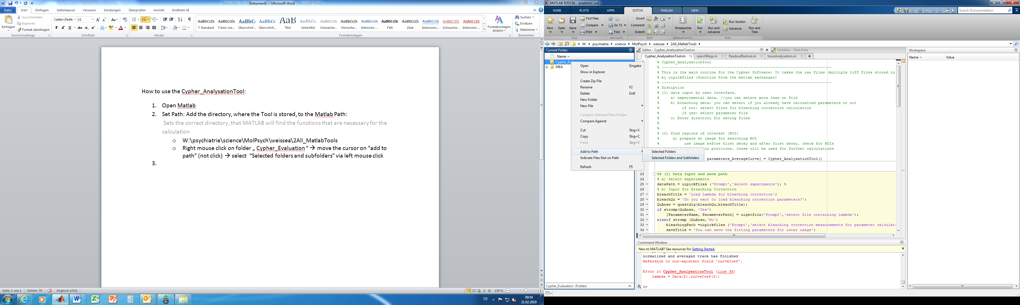

1. **Start the program**

* you can (1) **Press start (green play buttom)** or insert (2) Cy_Pher_Analysis() to the command line and press Enter

1. **Select Experiment Files**

* Select the files you want to analyse in the Explorer
* Multifile selection is possible

1. **User interface for loading bleaching parameters:**

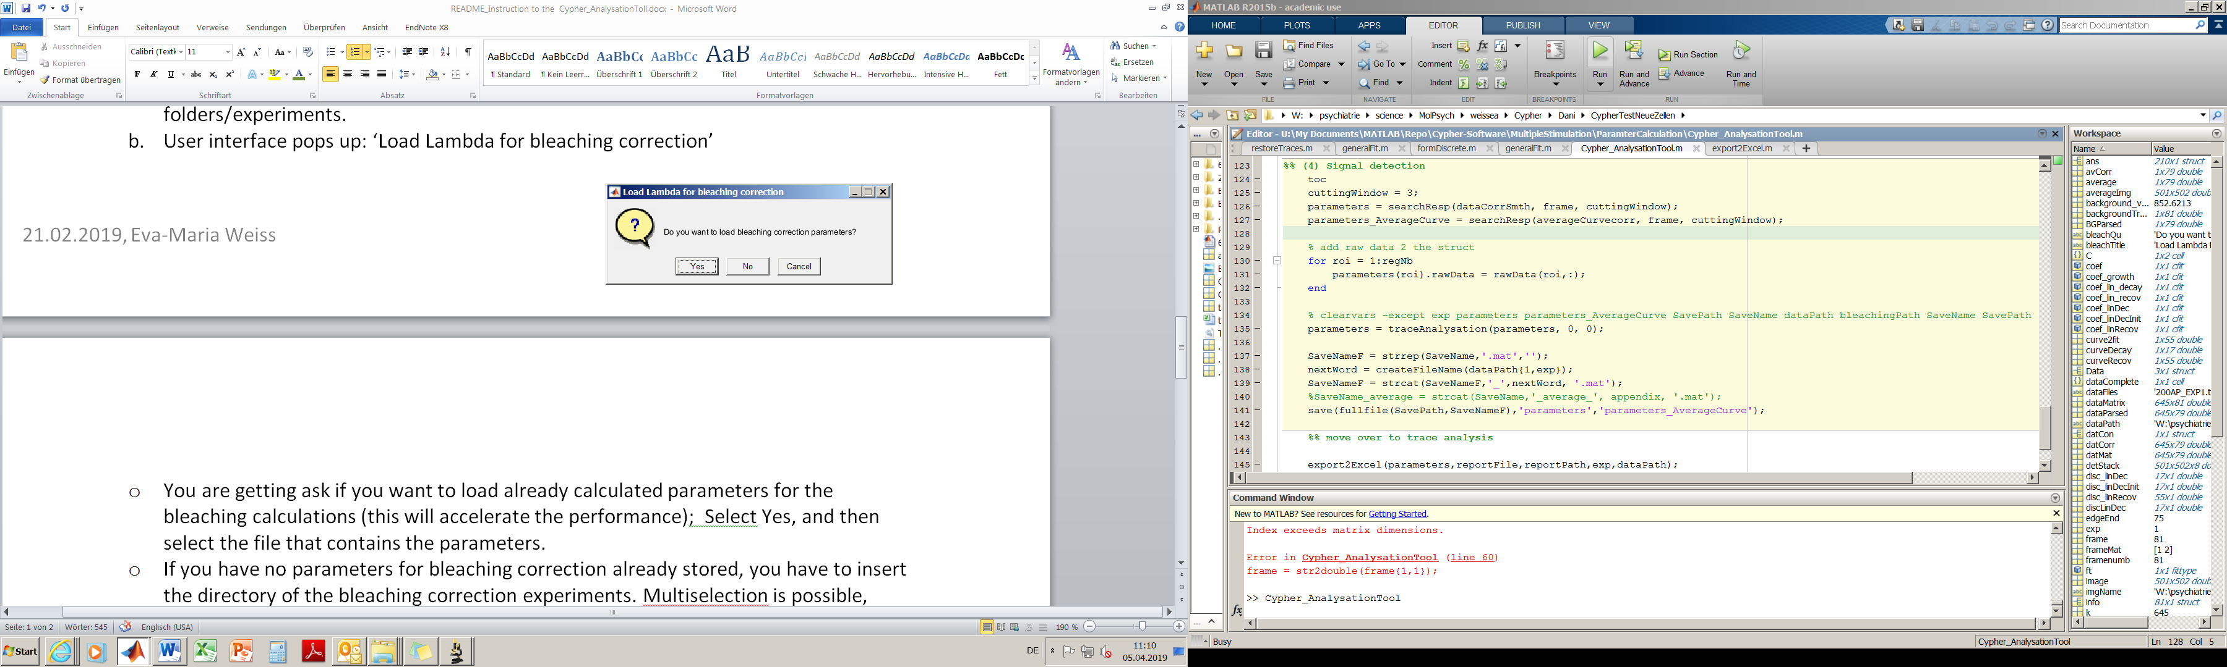

* **No:** you have no bleaching parameters already calculated (these are calculated during the first run, and can be stored during the process)
  + Select the data files of your bleaching experiments
  + Multiselection is possible, here the program averages the results;
  + Do you want to save the bleaching parameter on your computer? Select yes and select saving directory.
* **Yes:** you already have calculated and stored bleaching parameters ones, select the stored parameters in your directory (saved as a .mat file);

1. **Select directory to save your files:**

* During the analysis a matfile containing results is created for each experiment; The files are named according to the original filename, all matfiles that are created in one run are stored in the same folder.

1. **Name report File:**

* Excel files containing the results will be created for each experiment;
* Select folder and name: in the final filename the name you insert will be attached to the original filename so you have the prefix (original filename, specifying the file)_attachedName(specifying the run/group).xlxs;

1. **User Interface pops up ‘Enter frame number to top signal detection’:** enter the number of frame within stimulations were applied to precise signal detection;
2. **Explanation to ExcelFiles**:

* **Raw_data**: unprocessed data; one row for one synapses, one column for one time point/frame
* **Normalized_data**: restored traces; one row for one synapses, one column for one time point/frame
  + Subtraction of background
  + Correction for belaching
  + Normalization according to (F-Fmin)/(Fmax-Fmin);
* **Mean_Curve**: Average curve derived from all individual curves
* **deltaF_ allDetections**:
  + calculated change of fluorescence according to each stimulation resulted from the average curve(Mean_curve) and individual traced derived from each synpases (RoiNr.xy)
  + allDetections: all detected signals are involved



* **deltaF_justDecay**: negative signals are excluded (since a constant decay is expected)
* **statistics**: statistical evaluation of the results derived from the individual curves (RoiNr.xy)
  + mean value for each stimulation over all synapses: mean_over_synapses_per_stim
  + standard deviation for each stimulation over all synapses: standard_deviation
  + skewness for each stimulation over all synapses: skewness